GENERAL INFORMATION

SUBCATEGORIES OF GENERAL INFORMATION

**ACCOUNT AUTHENTICATION**

**ARTICLES IN ACCOUNT AUTHENTICATION**

Creating an account

User authentication

**USER ACCOUNT SETTINGS**

**ARTICLES IN USER ACCOUNT SETTINGS**

Selecting the language

Changing the password

**PERFORMING THE CALCULATIONS**

**ARTICLES IN PERFORMING THE CALCULATIONS**

Creating a project

Project name and description

Broadband connection calculation

Selecting required bandwidth calculation options

Selecting traffic profile

Selecting broadband connection technologies

LAN calculation

LAN configuration

**MANAGING THE PROJECTS**

**ARTICLES IN MANAGING THE PROJECTS**

Managing data entry template

Template

Manage project variables

Duplicating a project

Deleting a project

**ACCOUNT AUTHENTICATION**

GIGA Broadband Calculation Tool >> General information>> Account authentication

**CREATING AN ACCOUNT**

**Step 1**. Navigate to the Home page of the GIGA Broadband Calculation Tool website https://connectschools.online/#!/ (Figure 1.)

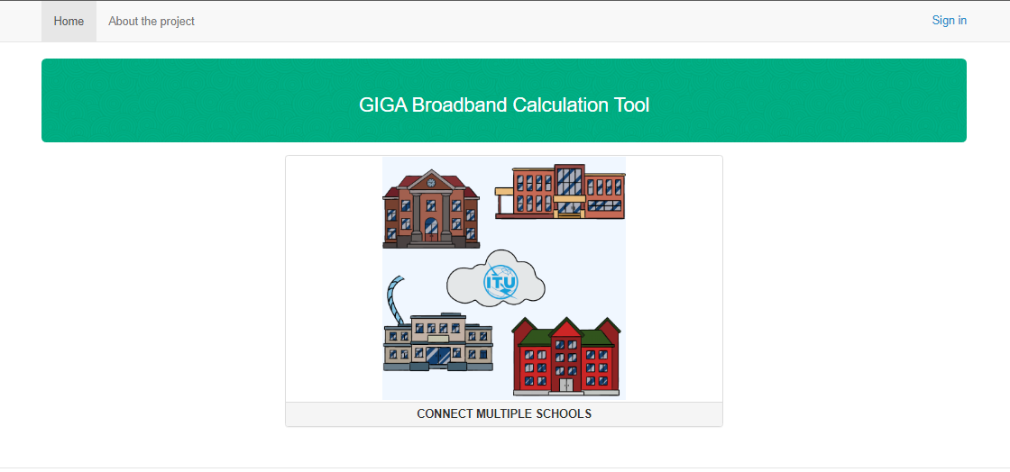

Figure 1. - Web Application Home page

**Step 2.** If you have already registered an account press click on "Sing in" button at the top right side of the window (Figure 2) or “Enter” under the “Send” button in “Registration form” window to go to the user authentication. (Figure 4)

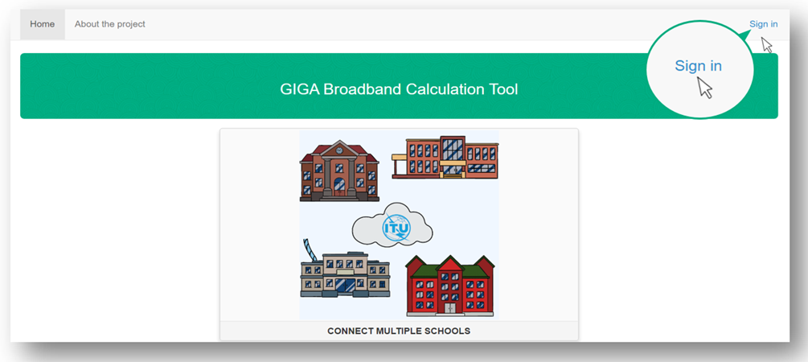

Figure 2. - "Sing in" button

**Step 3**. To open GIGA Broadband Calculation Tool’s “Registration form” click the banner, in the middle of the window, shown in Figure 3.

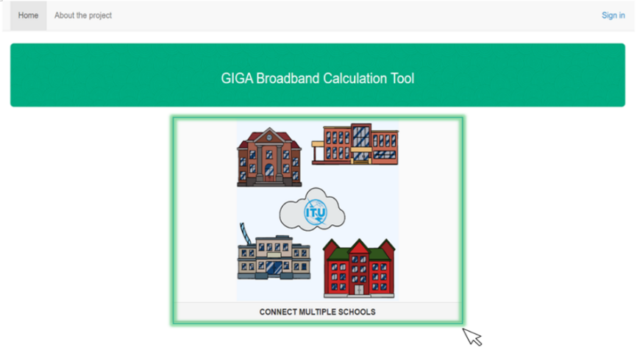

Figure 3. – Banner

**Step 4**. The “Registration form” will open in your browser and you will be asked to either register a new account or use an existing account. If you have not setup an account before, fill in the “Registration form”. (Figure 4)

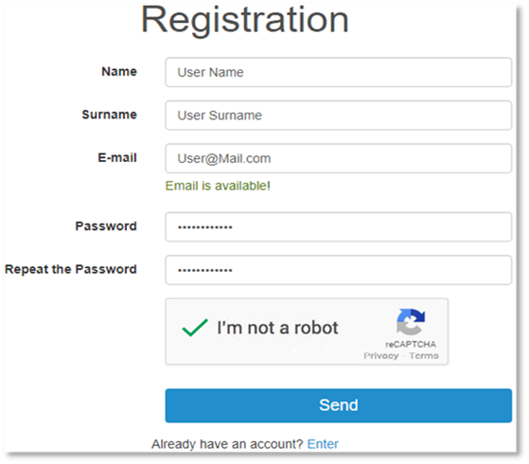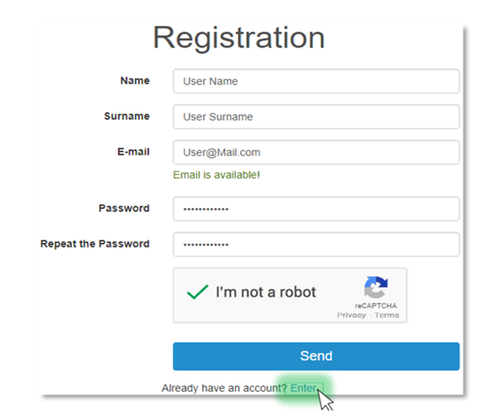

Figure 4. – Registration form

**Step 5**. Users will be asked to enter or select the following information (all items are required):

1. Text field for entering the name



2. Text field for entering the family name, Surname;



3. Text field for entering the email address, Email;

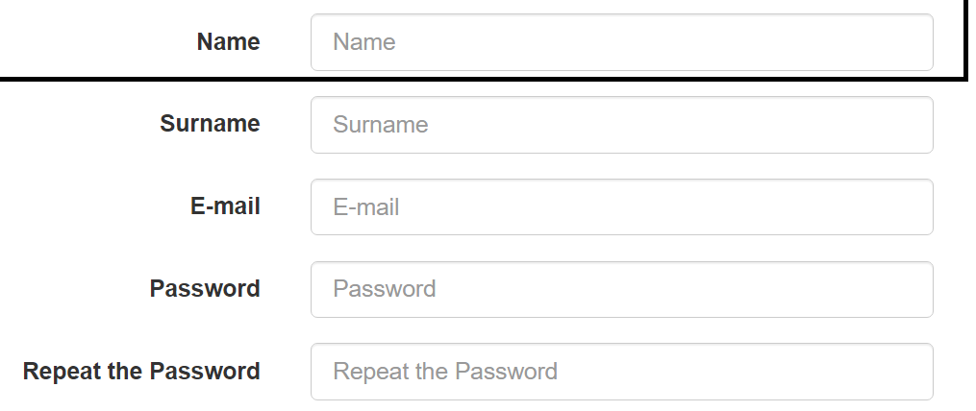

4. Text field for entering the password ! Password must be 8-32 characters long, consisting at least one number from 0-9, small and capital letters of the latin alphabet.



5. Text field for a security check, users will be asked to retype their password.



**!** In case of wrong password entering you will see nitification “MUST concide with the password in previous field.” To check your password click  button in the at the top right side of the field “Repeate the password”

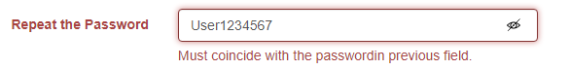

6. Malware Protection Component, reCAPTCHA

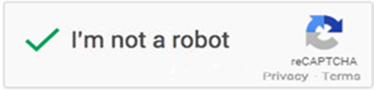

**Step 6**. After filling the “Registration form”, activate the malware check, ticking the option "I’m not a robot", select the appropriate images among those which appear on the screen and click "Verify" (Figure 5)

**Step 7.** If you select images correctly, the corresponding message “I’m not a robot” will be displayedClick "Send”.(Figure 6)

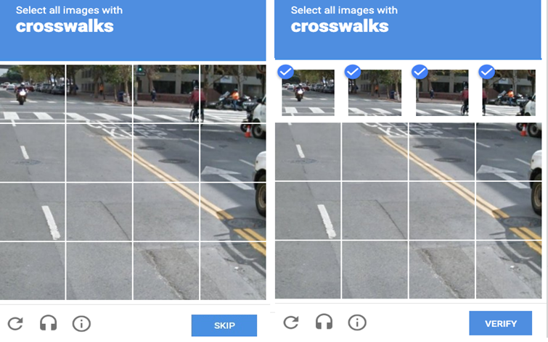

Figure 5. – reCAPTCHA window

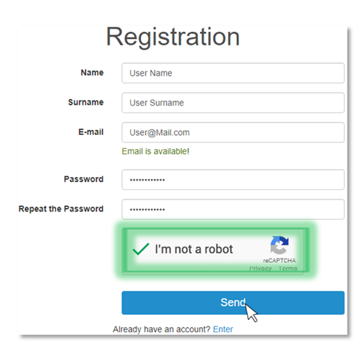

Figure 6.-Submitting the registration form.

Article is in the following categories: GIGA Broadband Calculation Tool >> General information>> Account authentication

**USER AUTHENTICATION**

**Step 1**. If you have already registered an account, fill in your login details. If you have no account press “Registration” under “Send” and go to Step 4 in “Creating an account”(Figure 1.)

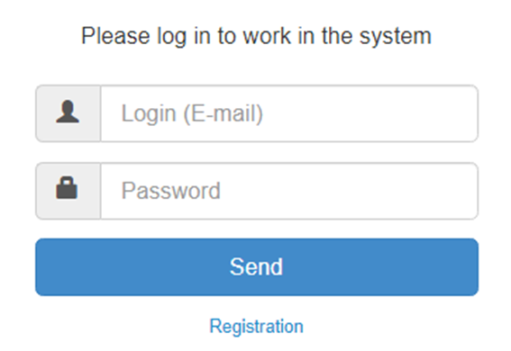

Figure 1. - Log in" form.

The log in form includes the following components:

1. Text field for entering the login( your E-mail address) ;

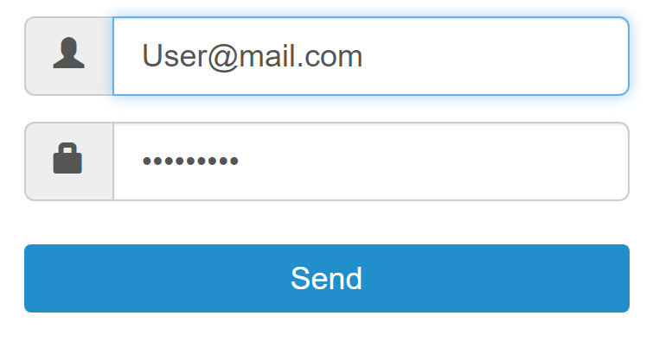

1. Text field for entering the password, Password.



**Step 2.** Press “SEND” to enter your profile (Figure 2).

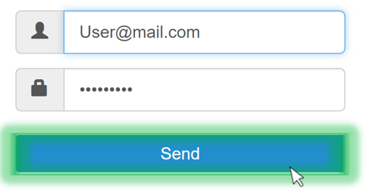

Figure 2. - Log in to the GIGA Broadband Calculation Tool.

After successfully creating an account and registering, you are ready to work in GIGA Broadband Calculation Tool.

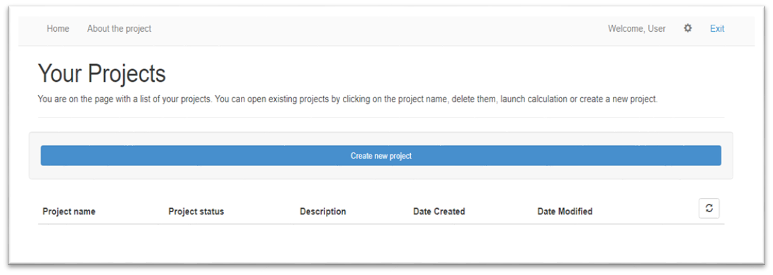

Figure 3. – GIGA Broadband Calculation Tool Account

Article is in the following categories: GIGA Broadband Calculation Tool >> General information>> Account authentication

**USER ACCOUNT SETTINGS**

GIGA Broadband Calculation Tool >> General information>> User account settings

**SELECTING THE LANGUAGE**

**Step 1**. The following process outlines how to set language an existing account. Please, press button, in the top right side of the window. In order to change settings (Figure 1)

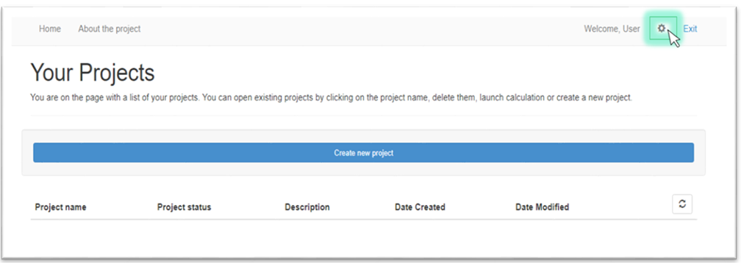

Figure 1. – Settings

**Step 2**. In “Settings” window, you will be able to change language by pressing button under sign “Site language”.( Figure 2)

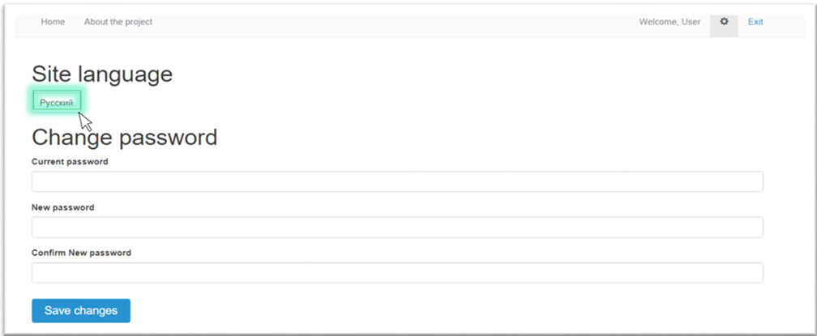

Figure 2. – Language change button

**Step 3**. Press “Save changes” button (Figure 3).

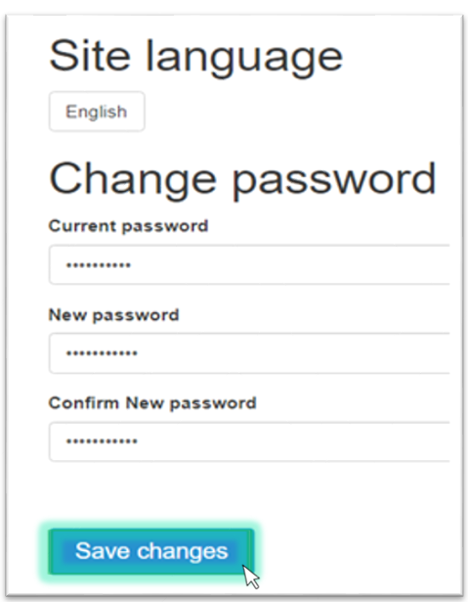  
Figure 3. – “Save changes” button

Article is in the following categories: GIGA Broadband Calculation Tool >> General information>> User account settings

**CHANGING THE PASSWORD**

Step 1. The following process outlines how to set password an existing account. Please, press button, in the top right side of the window. In order to change settings (Figure 1)



Figure 1. – Settings

**Step 2**. To change your password you need to fulfill the following components: current password, new password and conformation of new password. Figure 2

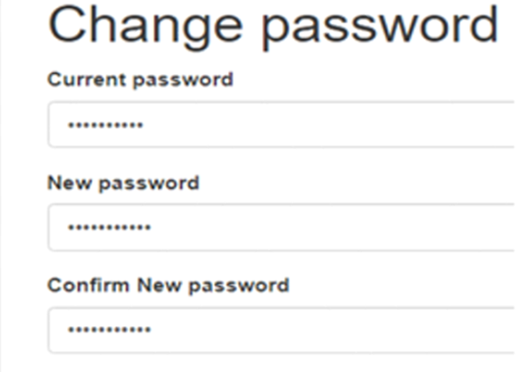

Figure 2. – Change password form.

**Step 3**. Press “Save changes” button (Figure 3). After this, you will see “Password changed successfully” above “Save changes” button. (Figure 4.).

  
Figure 3. – “Save changes” button

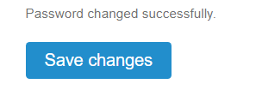

Figure 4– “Password changed successfully” notification

Article is in the following categories: GIGA Broadband Calculation Tool >> General information>> User account settings

**PERFORMING THE CALCULATIONS**

GIGA Broadband Calculation Tool >> General information>> PERFORMING THE CALCULATIONS

**CREATING A PROJECT**

The following process outlines how to create new project in a GIGA Broadband Calculation Tool. This program has eight different tabs, that are organized as a series of questions that provide for main user inputs. This section gives you step-by-step instructions for adding or revising data under each of the tabs.

Exploring the tabs of a GIGA Broadband Calculation Tool. Under each tab, the application presents one or more worksheets. Position the mouse pointer inside a worksheet cell, and click the mouse button to select this cell. If the cell is editable, you can then enter or change its value, for providing correct calculations for your project.

**Step 1**. Navigate to the Account tab on the main menu and select “Create New Project” in the center of Home page (Figure-1)

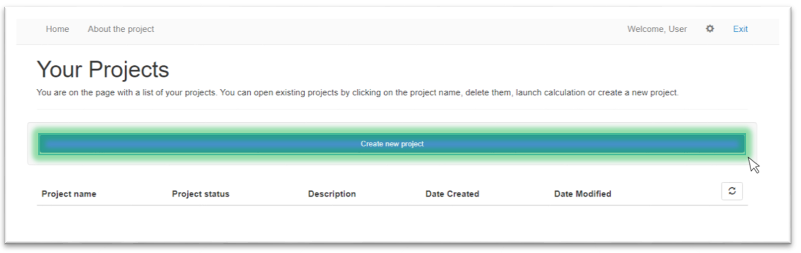

Figure 1– “Create Project” button

If you already created a project you can create the new one with duplicate button..

Article is in the following categories: GIGA Broadband Calculation Tool >> General information>> PERFORMING THE CALCULATIONS

**PROJECT NAME AND DESCRIPTION**

As soon as you log in to the system and click on “Create New Project” button you will be redirect to a new project page where you can submit some details about the new project. Project Name and Description tab displays following components that should be fulfilled: country name, project name and description of your project. (Figure 1)

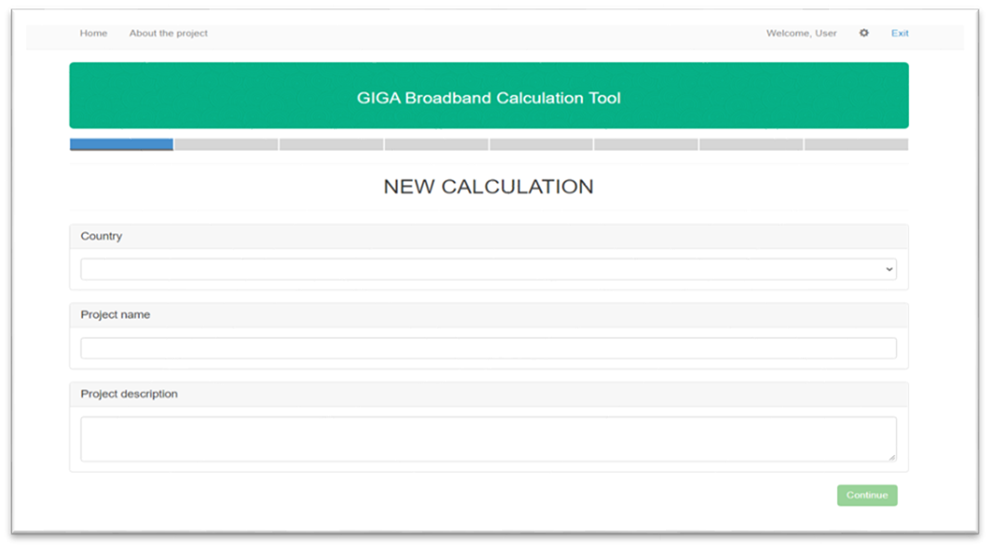

Figure 1– Project Name and Description tab

**Step 1.** Use the drop-down list to choose the country where your object located. (Figure 2)

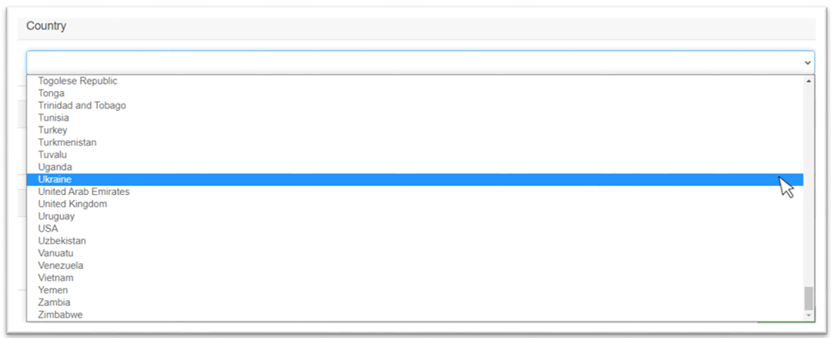

Figure 2– Drop-down list for selecting a country

**Step 2**. Input your project name. (Figure 3)

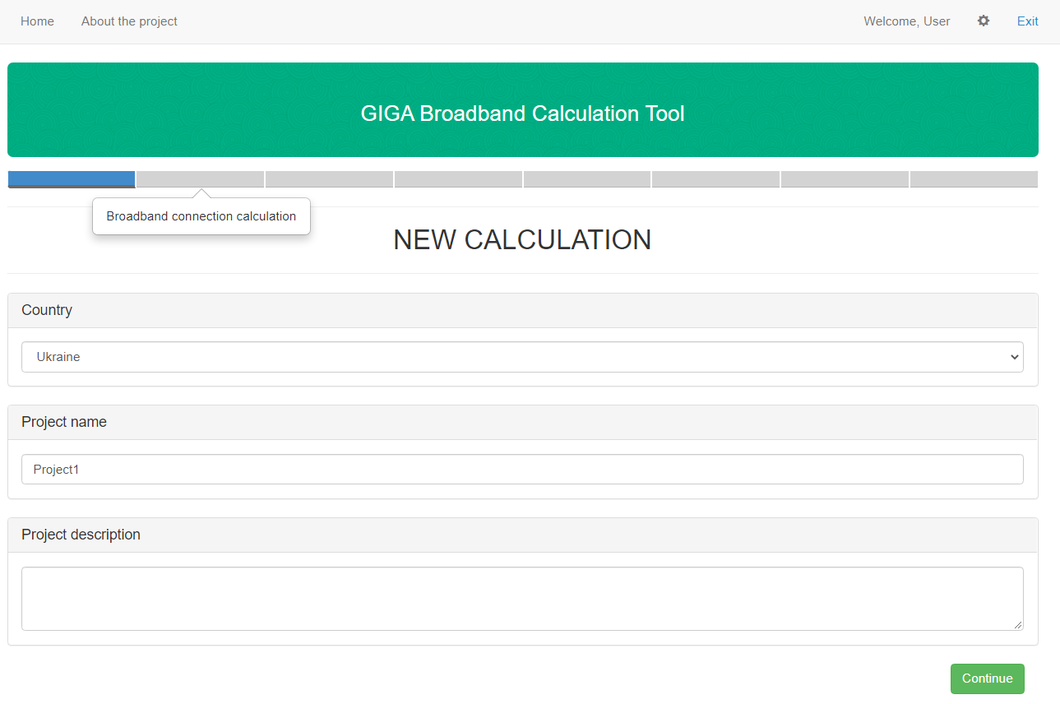

Figure 3– Project name field.

**Step 3.** Input your project description that will allow you to indentificate your project in system (Figure 4)

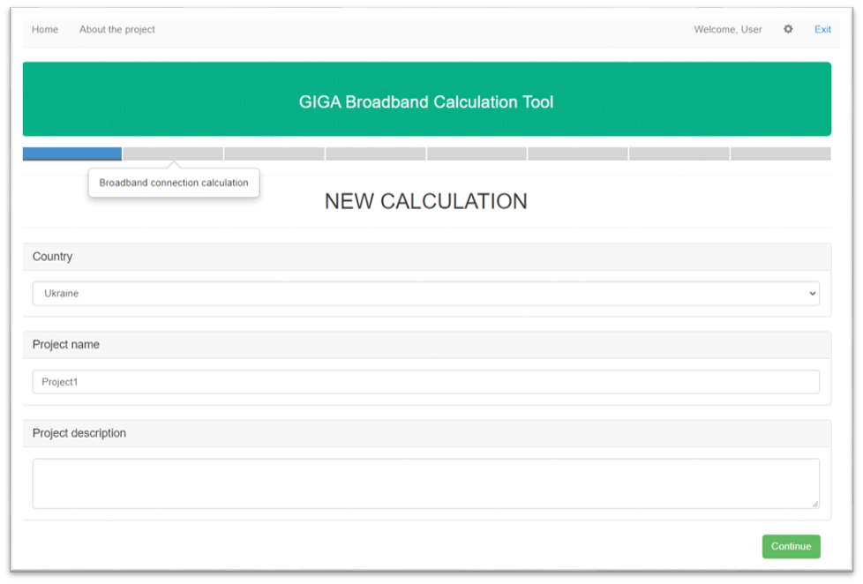

Figure 4– Project description field.

**Step 4.** Press “CONTINUE” in the bottom of the “Project Name and Description” window to go to the next tab. (Figure 5)

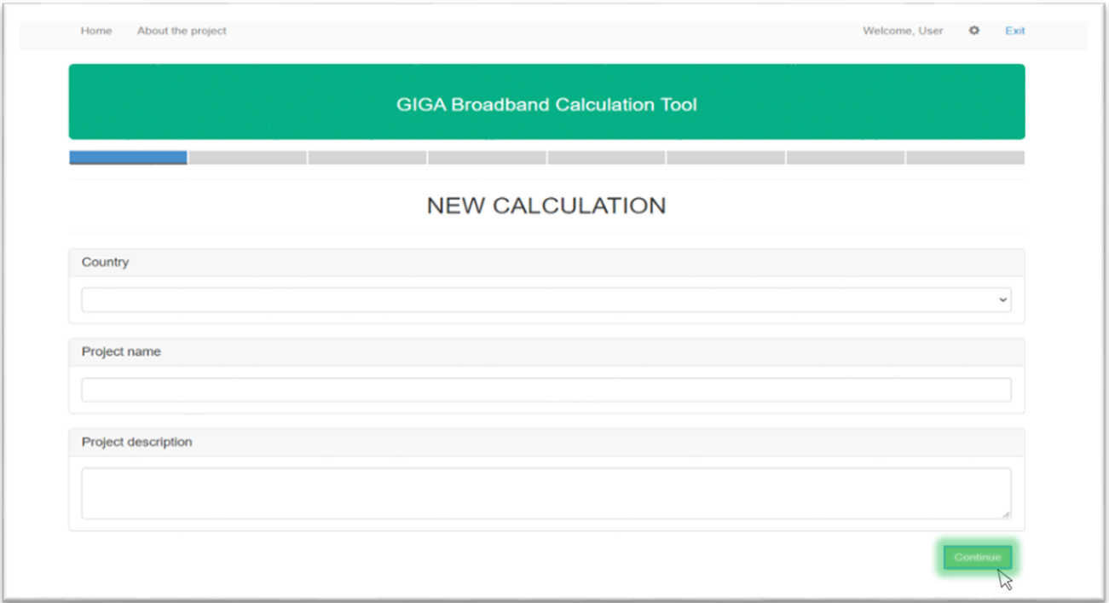

Figure 5– Project description field. “Continue” button

After this actions it will redirect you to the “**Broadband connection calculation”** **tab.**

Article is in the following categories: GIGA Broadband Calculation Tool >> General information>> PERFORMING THE CALCULATIONS

**BROADBAND CONNECTION CALCULATION**

After you input initial information about your project in previous tab in Project Name and Description part you’ll go to “Broadband connection calculation” tab.

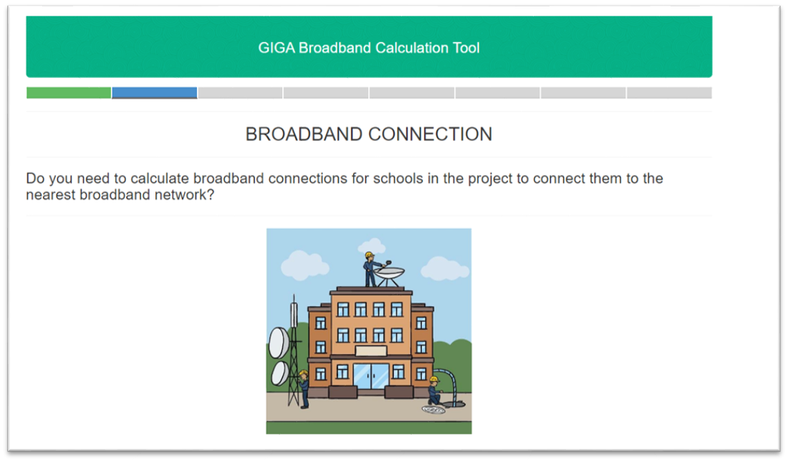

Figure 1– Broadband connection tab.

This tab offers you different options for broadband connection calculation. You can select one of 3 possible options:

By selecting “Calculation only broadband connection of schools to the nearest network points of presence (PoP)” іn the project it will be considered next positions: evaluation of broadband connection deployment and operation costs, estimation rates of return and selection of select suitable connection technologies. (Figure 2) After selection of this option you’ll go to tab “Calculation of required bandwidth”

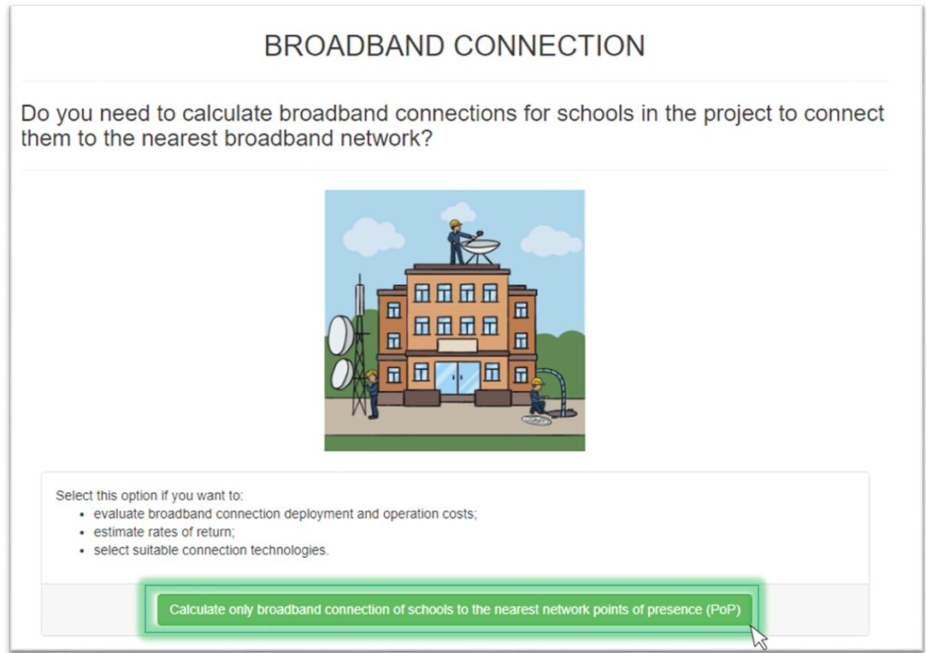

Figure 2- First option

By selecting “Calculation only broadband connection of schools to the nearest PoP with broadband connections between schools” it will be considered next positions: evaluation of broadband connection deployment and operation costs, estimation rates of return and selection of select suitable connection technologies and with calculation of an optimal (from the economic point of view) network structure where all schools are represented as interconnected network nodes. Also in this option you should select one of the following criteria that will meet your needs:

1. Cost of ownership – select this option if you would like us to use cost of ownership as a criterion to choose the best broadband connection options.
2. Net present value- select this option if you would like us to use net present value as a criterion to choose the best broadband connection options. (Figure 3.) After selection of this option you’ll go to tab “Calculation of required bandwidth”

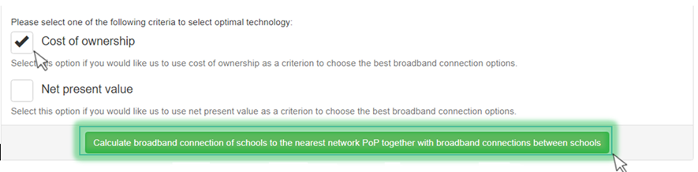

Figure 3- Broadband connection second option

By selecting “Skip Broadband connection calculation” you have an opertunity to skip all the forms, that are used for broadband connection calculations. After that you’ll go straight to **“Local area network”** tab. (Figure 4)

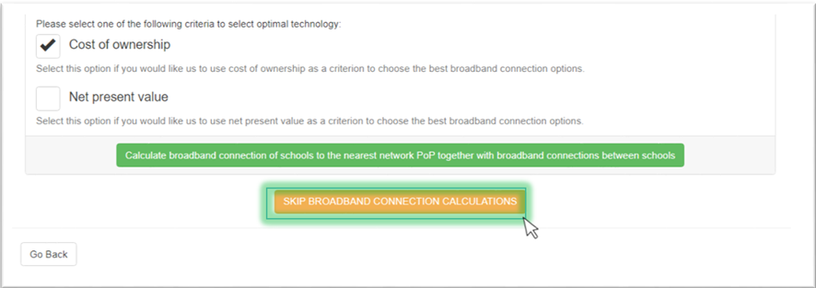

Figure 4- Broadband connection “SKIP” option

If you want to change parameters on previous tab select “Go back” button. After that you’ll go back to “PROJECT NAME AND DESCRIPTION” tab.

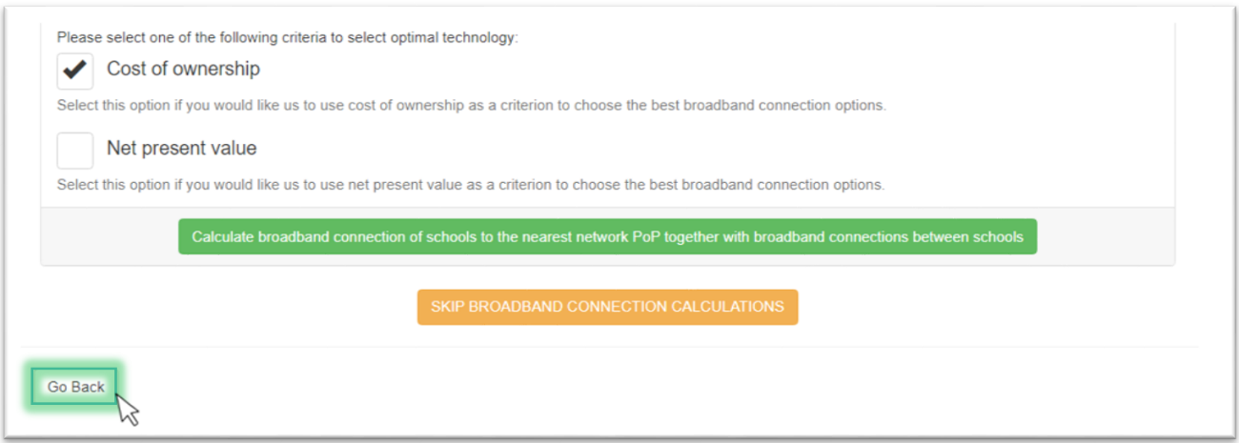

Figure 4-“Go back” button.

Article is in the following categories: GIGA Broadband Calculation Tool >> General information>> PERFORMING THE CALCULATIONS

**CALCULATION OF REQUIRED BANDWIDTH**

After selecting one of **broadband connection calculation** options, thecalculation of required bandwidth page opens. Now you can just choose one of the given options which helps you to find out required bandwidth for your project.

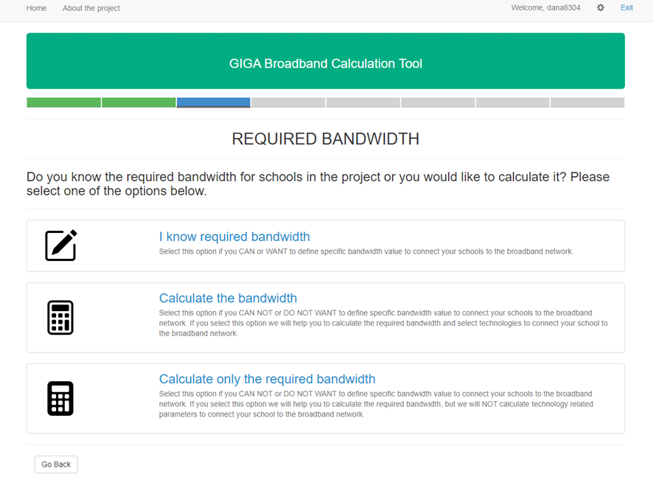

Figure 1 - Required bandwidth tab.

If you can or want to define specific bandwidth value to connect your schools to the broadband network yourself select first option “I know required bandwidth” button. (Figure 2) After this you skip “Traffic calculation” tab and you’ll go straight to to” BROADBAND CONNECTION TECHNOLOGIES” tab.

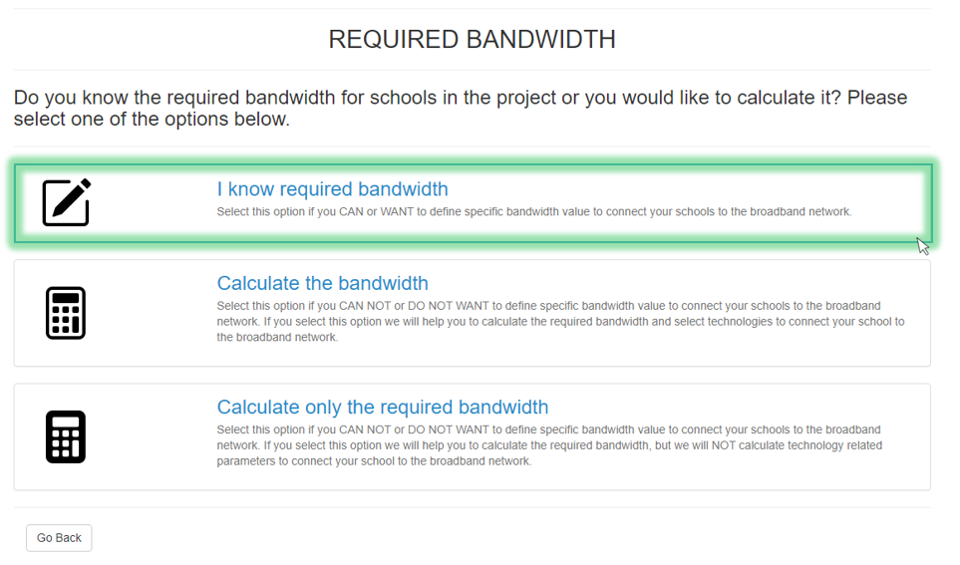

Figure 2-“I know required bandwidth” button.

If you need help in bandwidth calculation, select one of two other options.

Here you can:

* Calculate the required bandwidth and select technologies to connect your school to the broadband network (Figure 3)
* Calculate the required bandwidth, but without technology related parameters calculation. (Figure 4).

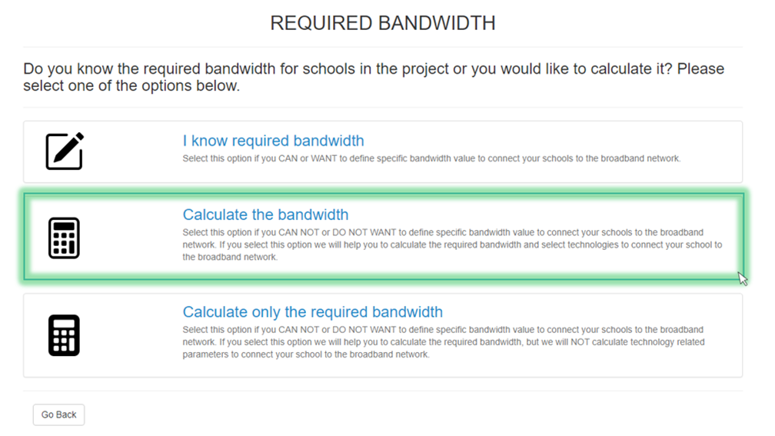

Figure 3 - “Calculate the bandwidth” option

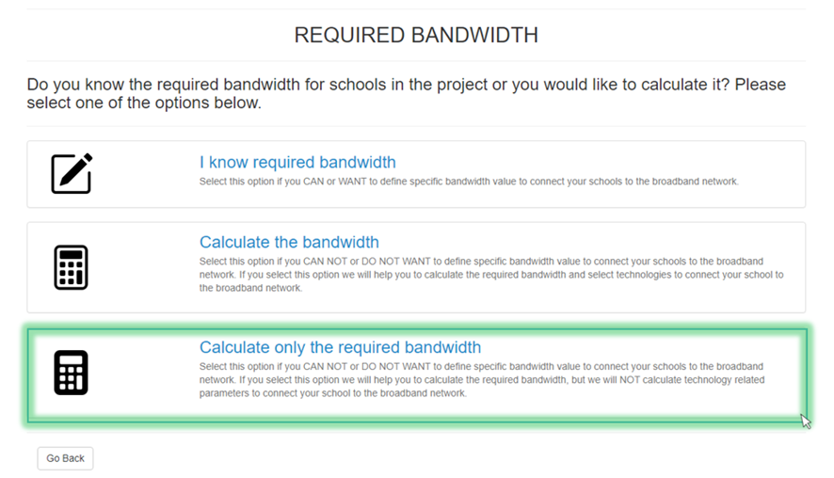

Figure 4 - “Calculate only the required bandwidth” option

After that you’ll go straight to “Traffic profile” tab.

If you want to change parameters on previous tab, select “Go back” button. After that you’ll go back to “Broadband connection” tab. (Figure 5)

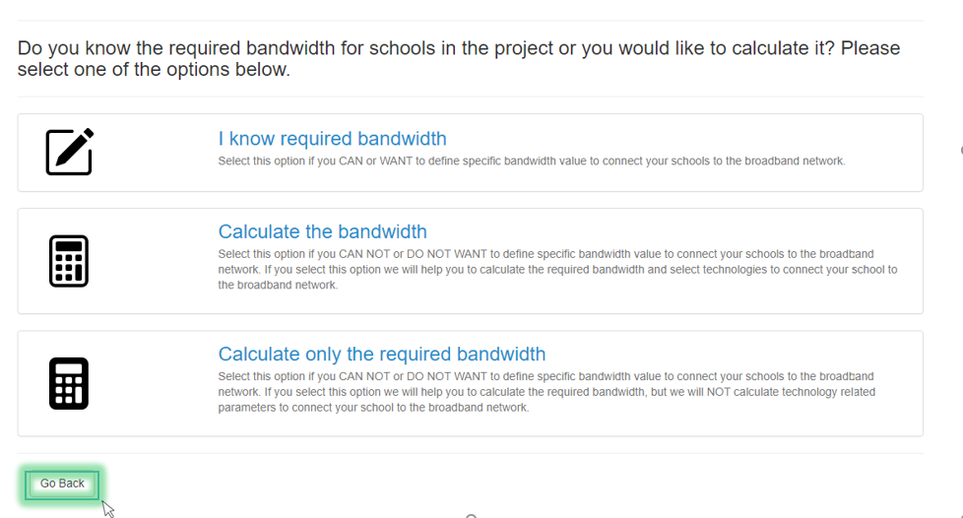

Figure 5- “Go back” button.

**Article is in the following categories:** GIGA Broadband Calculation Tool >> General information>> PERFORMING THE CALCULATIONS<< Return to Referring page

**SELECTING TRAFFIC PROFILE**

Traffic profile gives you an option to choose necessary services consumption intensity and quality of services parameters that will be used in your network.

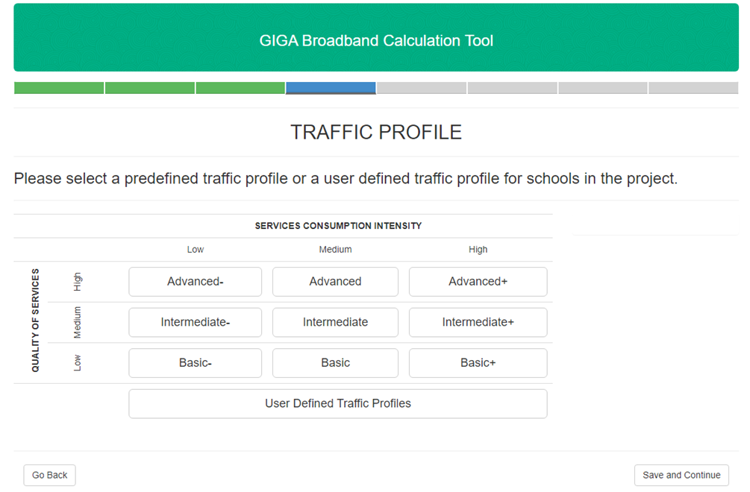

Figure 1- “TRAFFIC PROFILE” tab.

Services consumption intensity – describes intensity of particular service usage (large, middle and small number of simultaneous sessions).

Quality of services parameters- shows what level of connection qualiy during major part of the time (high delay and non-stable connection, medium delay and stable connection or low delay and stable connection all the time).

You can combine this two parameters to select the most sutable option among nine ofered predefined variants in table (Figure 2)

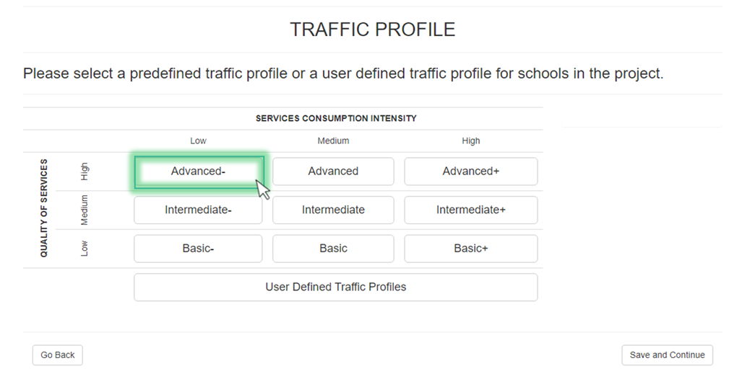

Figure 2- Traffic parameters selection

You can also easily create your own traffic profile. Select the “User Defined Traffic Profiles” option and click on “Add new profile” button.

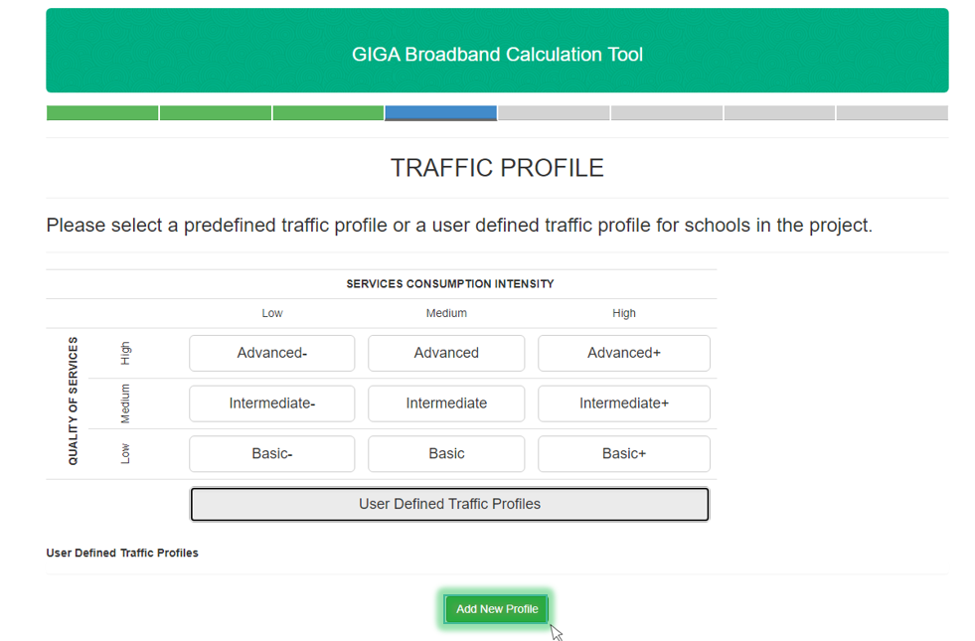

Figure 3- User Defined Traffic Profile

When you click on “Add new profile” button, you’ll be redirected to traffic profile generator.

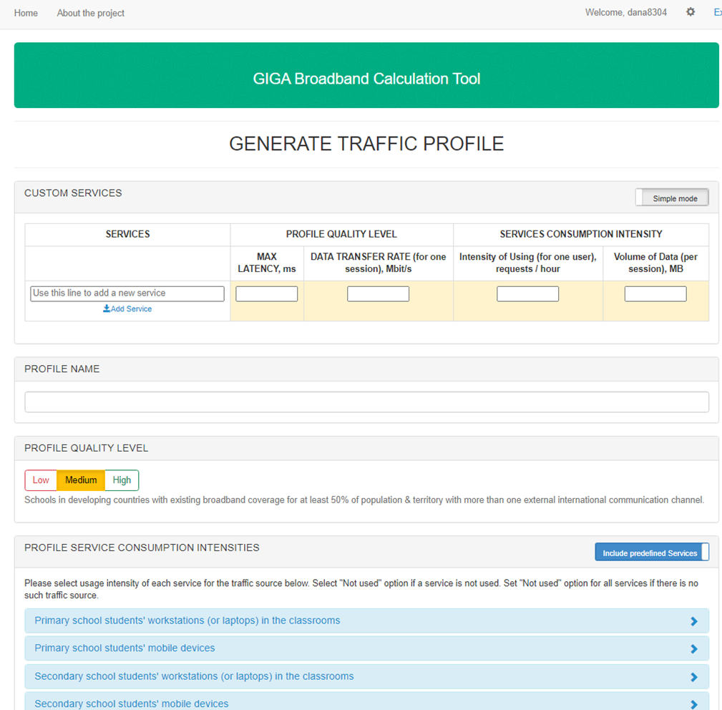

Figure 4- Traffic Profile Generator

There are only two types of fulfilling “PROFILE SERVICE CONSUMPTION INTENSITIES” field, only Customer service or Predefined Services option. It is important to indicate which option you need. Predefined Services option gives more diverse choice of services you use, when “Customer service” only include intensities of customer service device. (Figure 5)

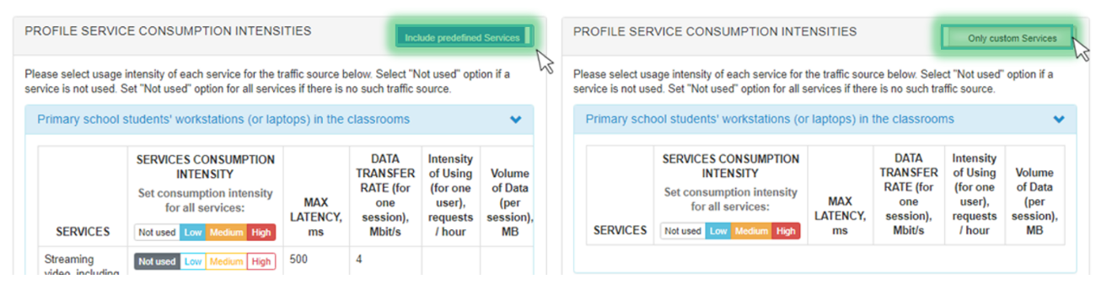

Figure 5- Service consumption intensities options

“Predefined Services” option. Select usage intensity of each service for the traffic source in “Service consumption intensity” field in following table “Predefined Services option”. Select "Not used" option if a service is not used. Set "Not used" option for all services if there is no such traffic source. ШТ( Figure 6)

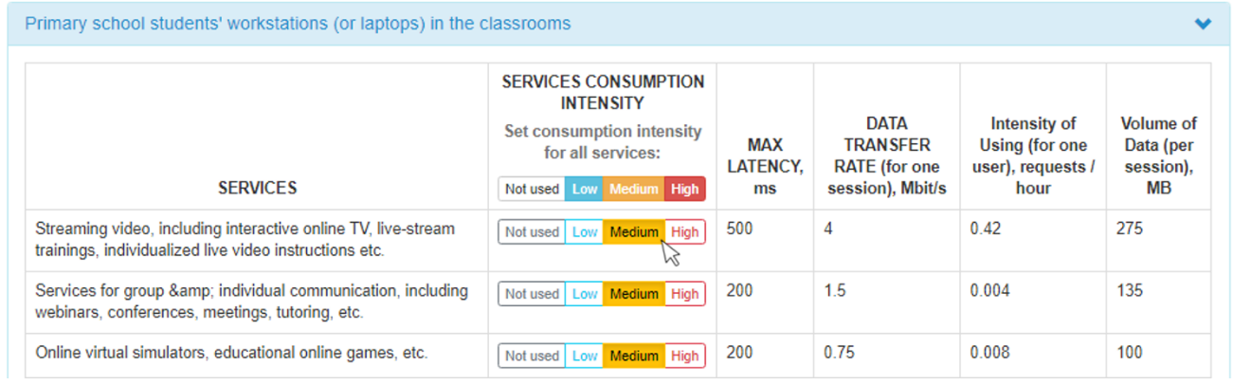

Figure 6- Predefined Services option

In “Profile quality level” table select one of three possible options.( Figure 7) Here you can choose:

1. Low. For Schools in hard-to-reach areas (including rural) in the countries where the internal backbone is not developed now and/or the external connectivity to the international communication channels is poor.

2. Medium. For Schools in developing countries with existing broadband coverage for at least 50% of population & territory with more than one external international communication channel.

3 High. For Schools in developed countries with good broadband coverage and international communication channels.

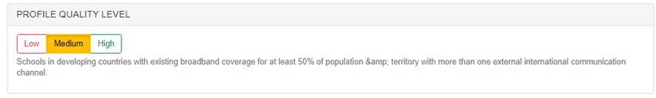

Figure 7- “Profile quality level” option

In “profile name” field you write the name of your own “Traffic Profile” parameters. Which will be saved in system under the name you’ve select. (Figure 8)

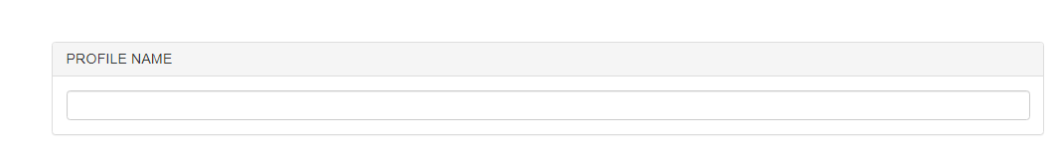

Figure 8- “Profile name” field

In table “Custom services” table you can add new services that are not included in “PROFILE SERVICE CONSUMPTION INTENSITIES” field including their individual parameters. Also you can do in in simple or extended mode. In “Simple mode” you input average parameters for your service, when in extended mode you can input parameters for different quality levels for each service. (Figure 9)

i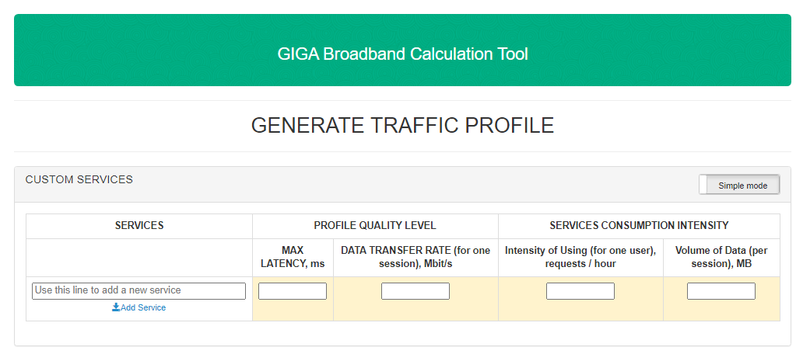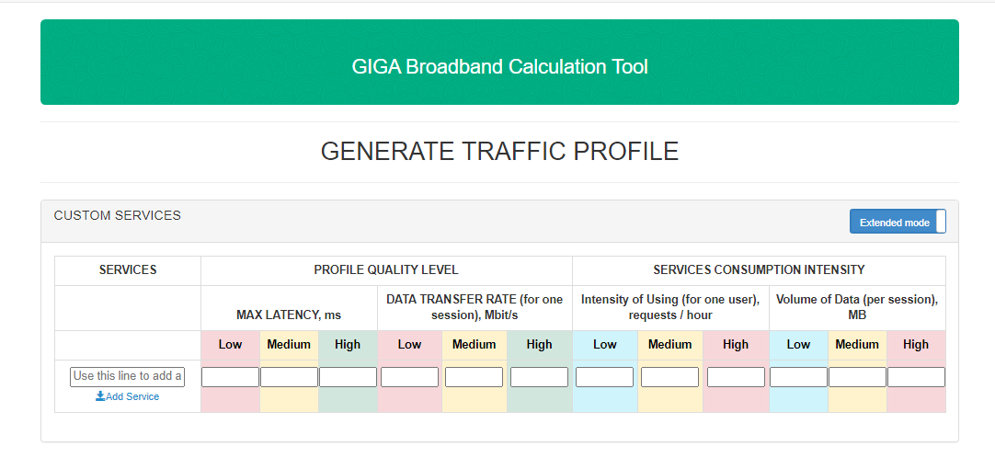

Figure 9- “Custom services”

Click “Save and Continue” in the bottom of the page to save your parameters. You’ll be redirected to “traffic profile” page (Figure 10)

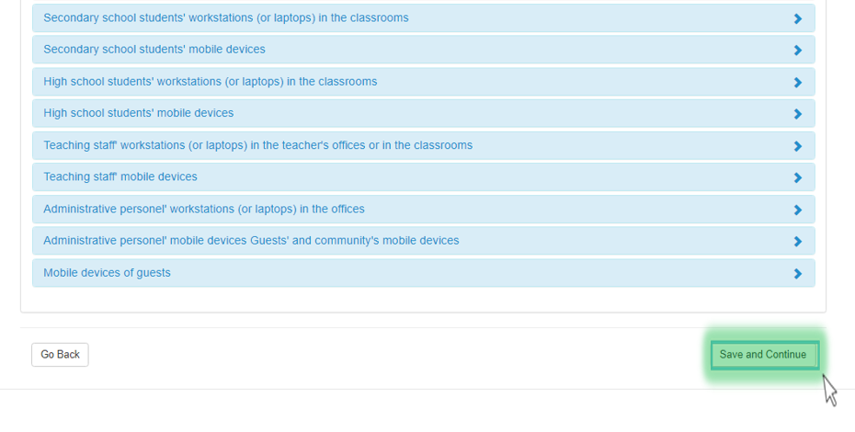

Figure 10 - “Save and continue” button

Also you can change/ delate the formatting of your parameters them or add new one in “User defined Traffic profile” settings in “traffic profile” tab.

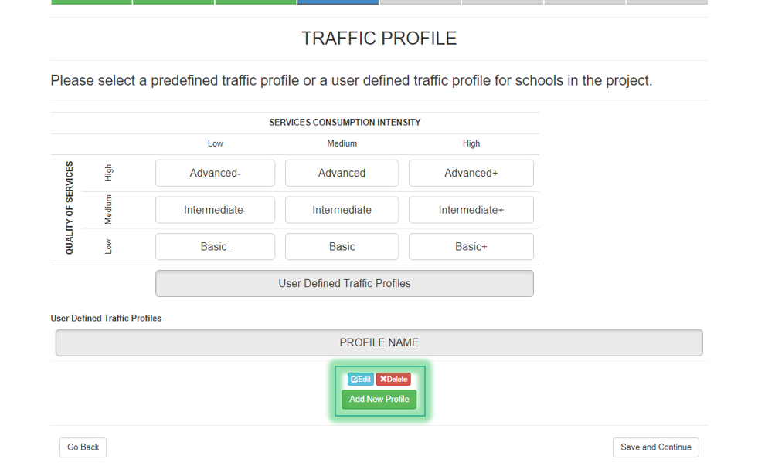

Figure 10 - User defined Traffic profile settings

Click “Save and Continue” in the bottom of the page.

**SELECTING BROADBAND CONNECTION TECHNOLOGIES**

Select technology that could be used for broadband connections between schools. There are four types of broadband connections:

1. Fiber optical cable line- this type of broadband connection usually installed in-ground (often along the roads), in cable duct or overhead via poles;
2. Mobile cellular network- this type of broadband connection - available only in places with 3G/4G mobile coverage;
3. Microwave radio link- this type of broadband connection usually requires towers, radio equipment and spectrum licensing;
4. Satellite communication link- this type of broadband connection available in any place of the world;   
    ! Here you should select at least one technology !  
   Select one or all variants of broadband connection, that will be included in project calculations.

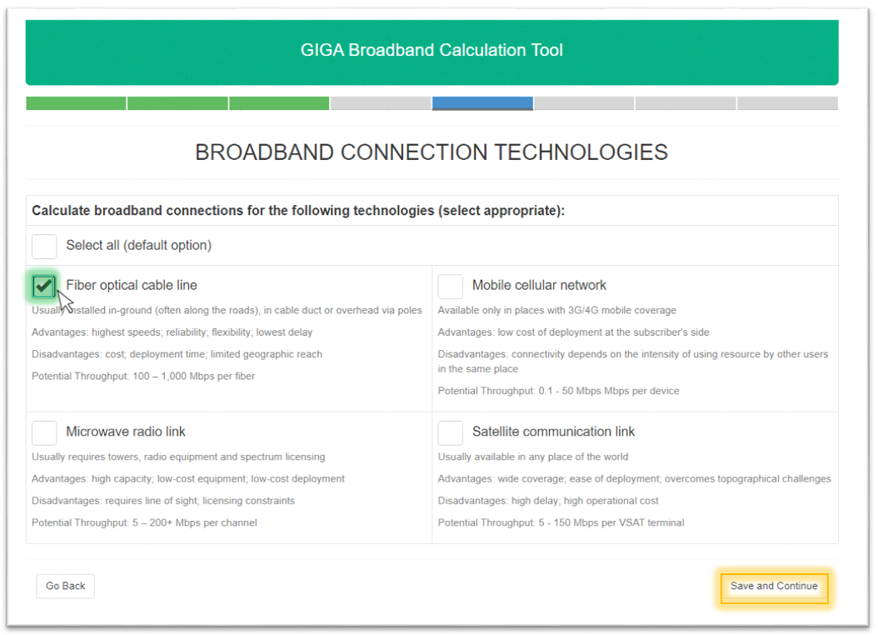

Figure 1. – Broadband connection technologies tab

Press “Save and Continue” to continue

**LAN CALCULATION**

If you want to calculate local area network select “Calculate button” or skip this tab. Choose this step if you want to select suitable local area network configurations and evaluate local area network deployment and operation costs. After that you will be redirected to “LAN configuration”. If you skip this tab you’ll go to “Calculation settings” tab.

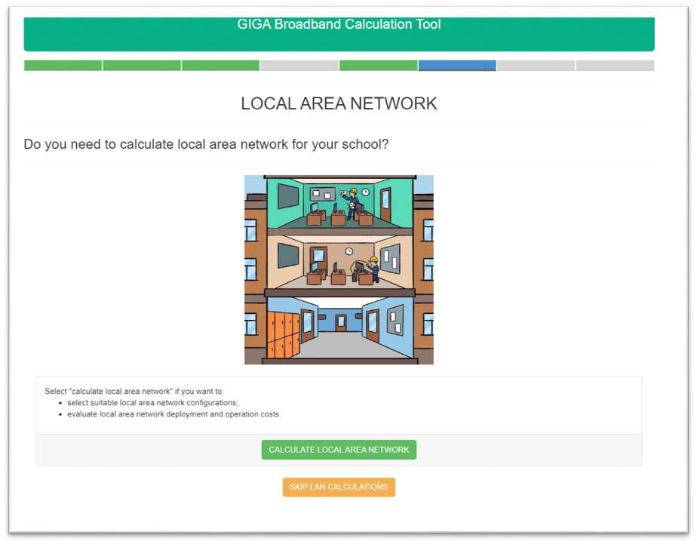

Figure 1. – Broadband connection technologies tab

**LAN CONFIGURATION**

Select local area network segments that you want to calculate for your school. You can chose one or several options from given ones.

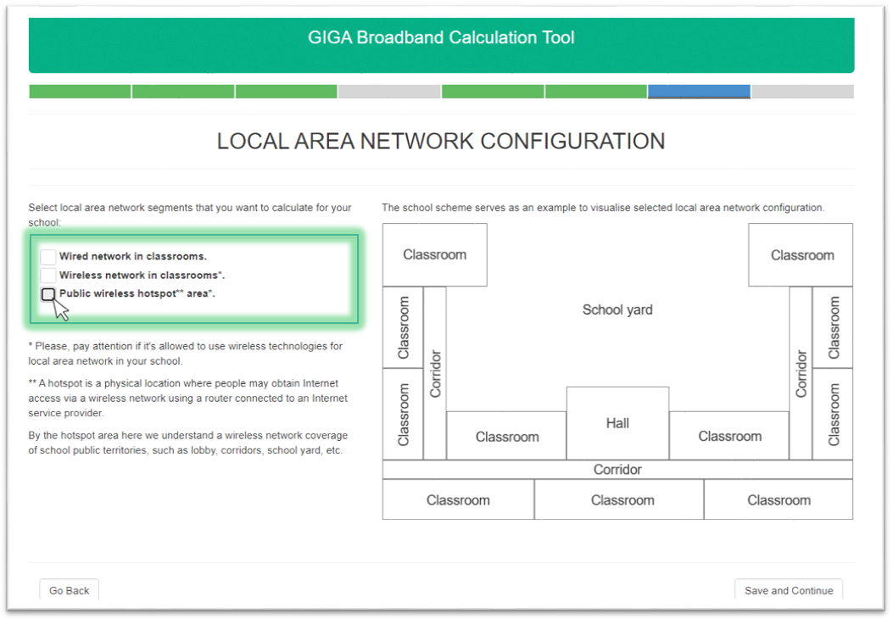

Figure 1. – Broadband connection technologies tab

In the right part of the window you can see the scheme that can help you to visualize selected local area network configuration. It depends on your selection.

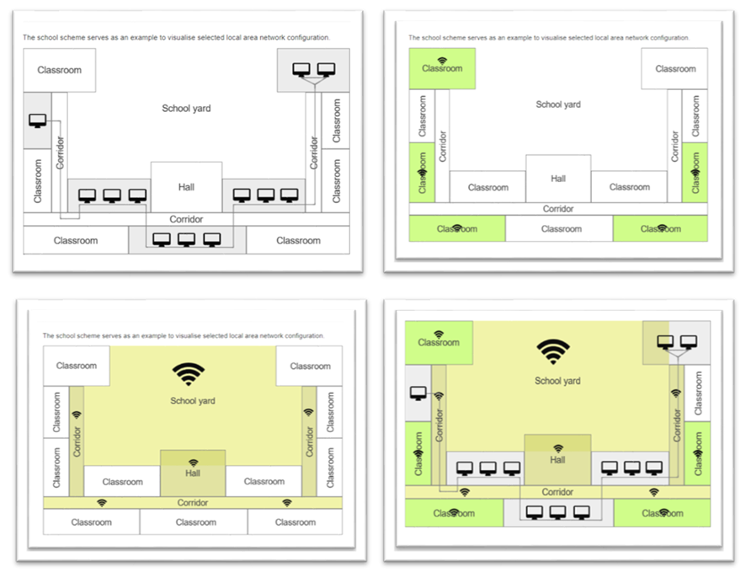

Figure 1. – Local area network segments schemes variations

! Please, pay attention if it's allowed to use wireless technologies for local area network in your school.

!! A hotspot is a physical location where people may obtain Internet access via a wireless network using a router connected to an Internet service provider.

!!! By the hotspot area here we understand a wireless network coverage of school public territories, such as lobby, corridors, school yard, etc.

**CALCULATION SETTINGS**

In this tab you can check all of the settings calculation settings you've chosen before. In this tab you can check all of the settings calculation settings you've chosen before. These calculation settings for the project can't be changed after submitting and saving

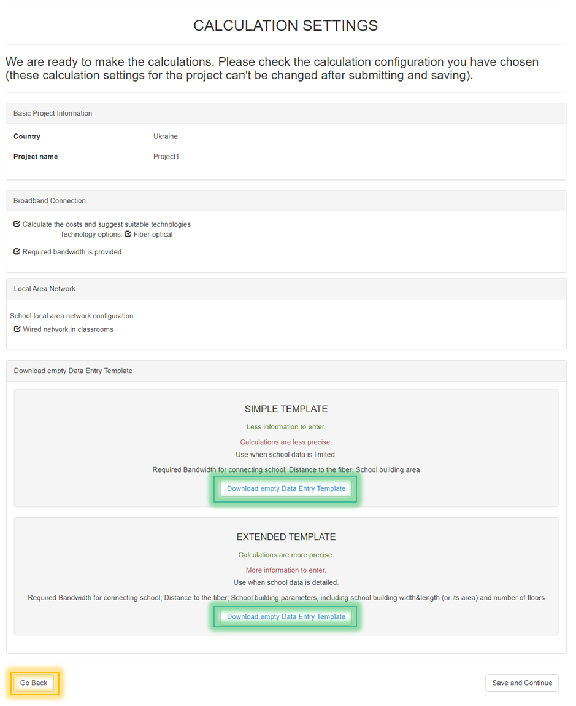

Figure 1. – Project Information

Also here you can download **templates**. This templates should be fulfilled and lately you should upload them to the project (Managing data entry template), to obtain correct calculations

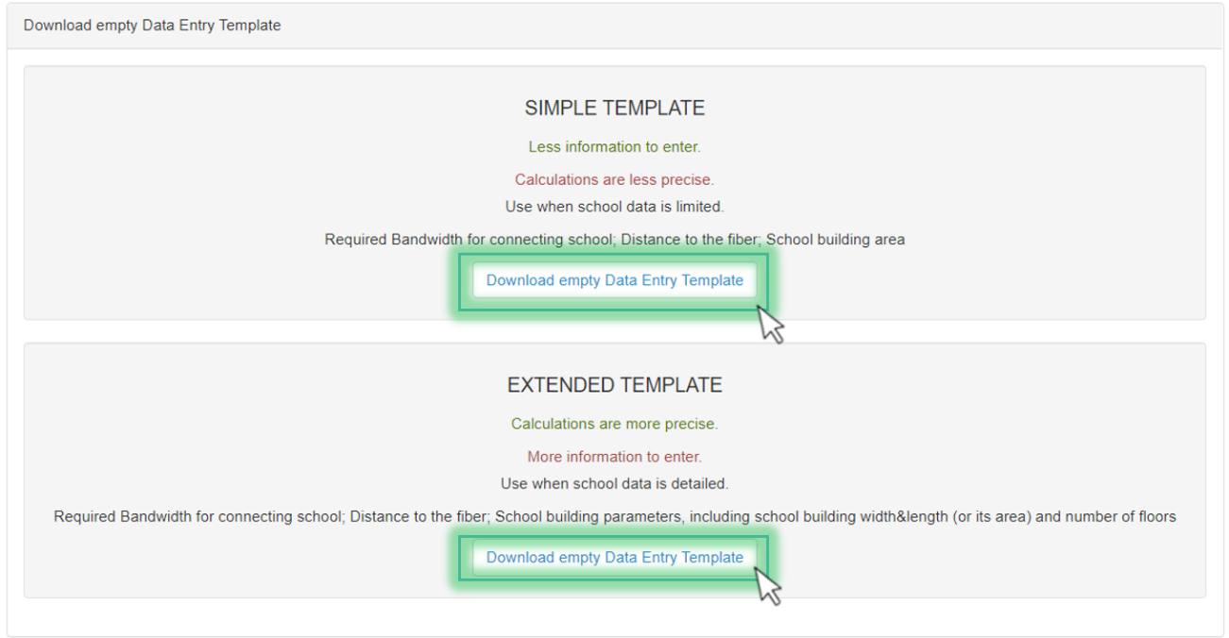

Figure 2. – Templates downloading

Press “Save and Continue” to continue. After this you’ll see “Home page” with created project(Figure 3). You can see there: project name, project status,description,date of creation and date of modification

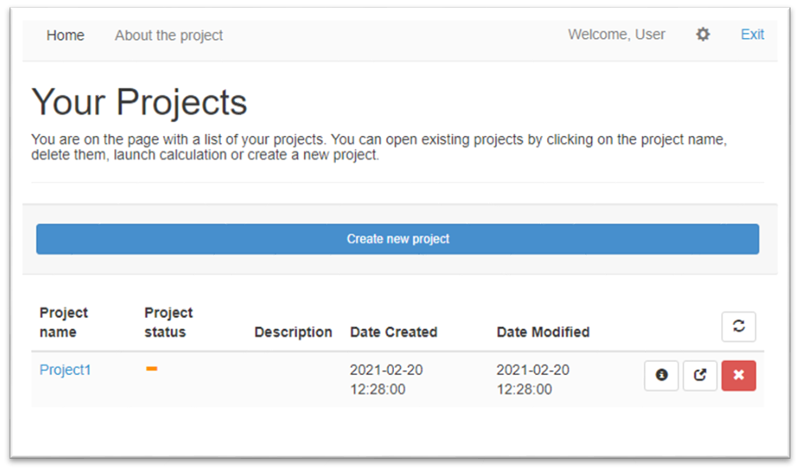

Figure 3. – Home page

**MANAGING THE PROJECTS**

GIGA Broadband Calculation Tool >> General information>> MANAGING THE PROJECTS

**ARTICLES IN MANAGING THE PROJECTS**

**MANAGING DATA ENTRY TEMPLATE**

By clicking on project name so you have further options to customize your file. Here you can add variables for obtain your project.

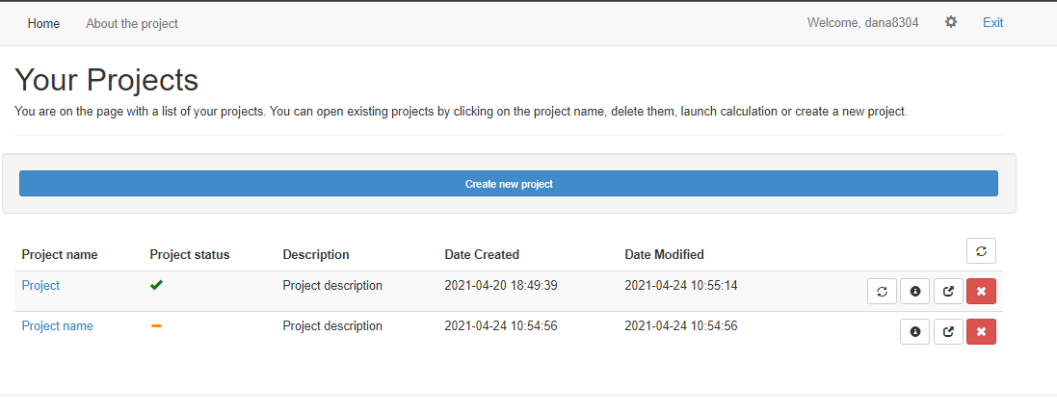

Figure 1. – Home page

You can view here all project data of your project. If you have downloaded templates in CALCULATION SETTINGS please upload them clicking on button “Upload Newe file” in “Managing data entry template” field. Or here you can also download one of given **templates**. (Figure 2)

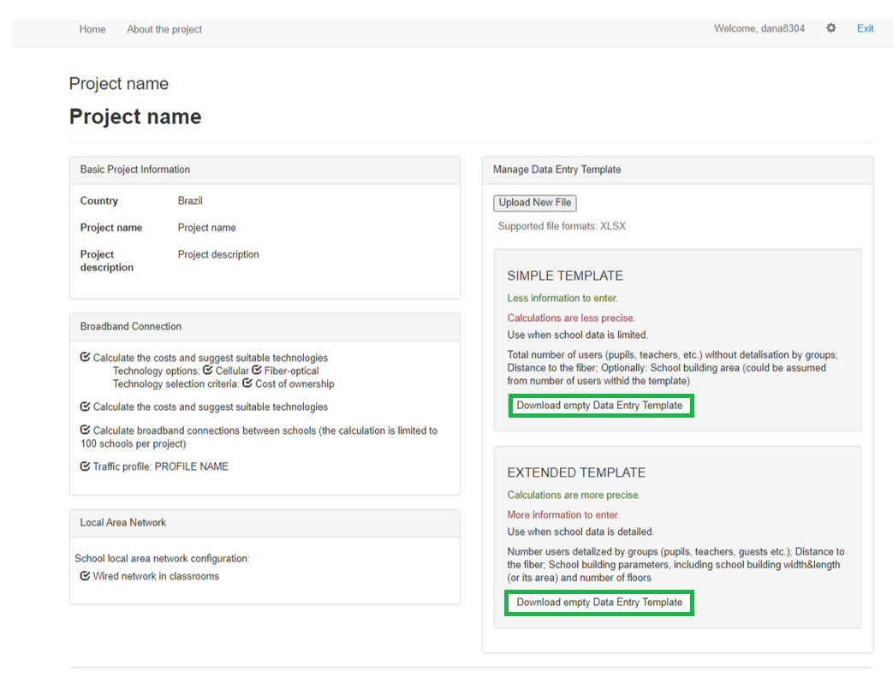

Figure 2. – Templates downloading

**TEMPLATE**

Types of templates:

Simple template - use when school data is limited. (Required Bandwidth for connecting school; Distance to the fiber; School building area).

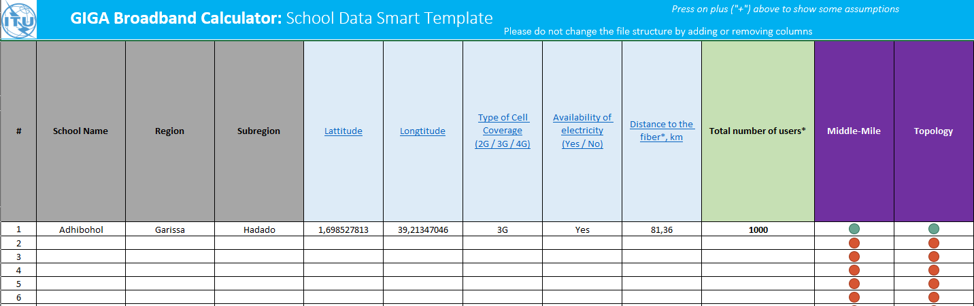

Figure 2. – Simple template

Here you can enter all the content you need:

School Identification - (this section is used only for unique identification of school, but does not used for calculations. All of these fields could be missed, in this case objects (schools) will receive automatic names during the data import (f.e. School #1, School #2 etc.)

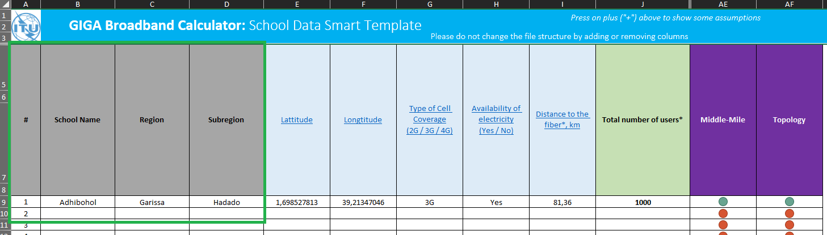

Figure 3. – School Identification

Geographical Location and Infrastructure Presence - this section is used by methodology of connecting schools to broadband transport backbones. Parameters that you should enter: Latitude; Longtitude; Type of Cell Coverage (2G / 3G / 4G); Availability of electricity, Distance to the fiber

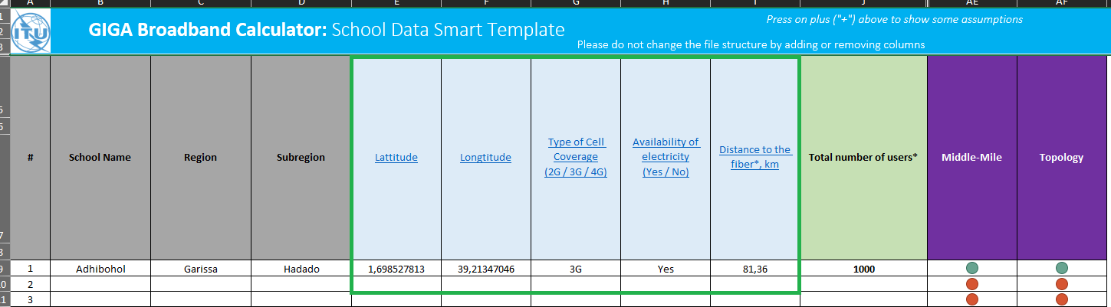

Figure 4. – Geographical Location and Infrastructure Presence

Users - this section is used for calculation number of devices that will be used in school.

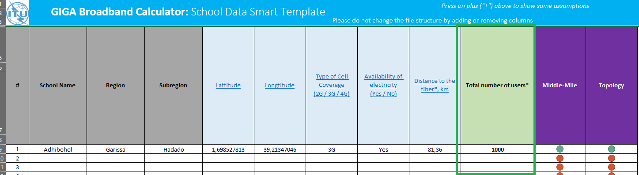

Figure 5. – Users

Data entering completeness - this section is used for demonstrating if it is all necessary information was interred for particular school (in the row) for future processing and calculations.

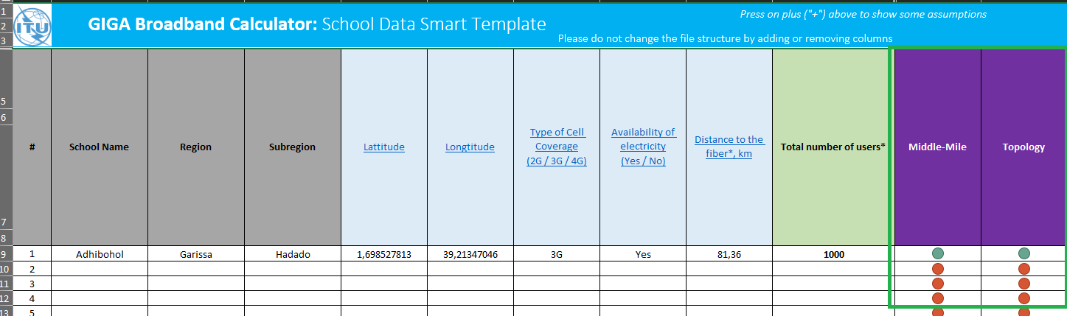

Figure 6. – Data entering completeness

Extended template - Use when school data is detailed. (Required Bandwidth for connecting school; Distance to the fiber; School building parameters, including school building width & length (or its area) and number of floors). If it is necessary you can return to previous steps using “Go Back” button (Marked in yellow). In Extended template you have more classified variables in “Users“ parameters.

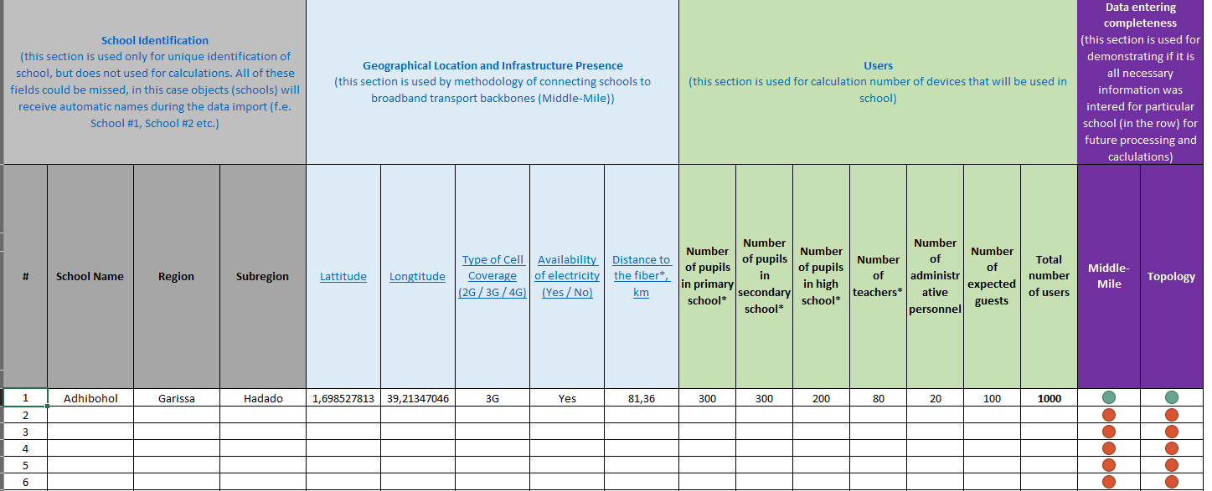

Figure 7. – Extended template

**MANAGE PROJECT VARIABLES**

Also here you can change “Manage Project Variables” if you do not agree with program ones. Download “Project Variables Template” using button . Fill in teamplate and upload them to the project by using  button. If you want to reset variables to default ones click 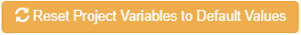 (Figure 1)

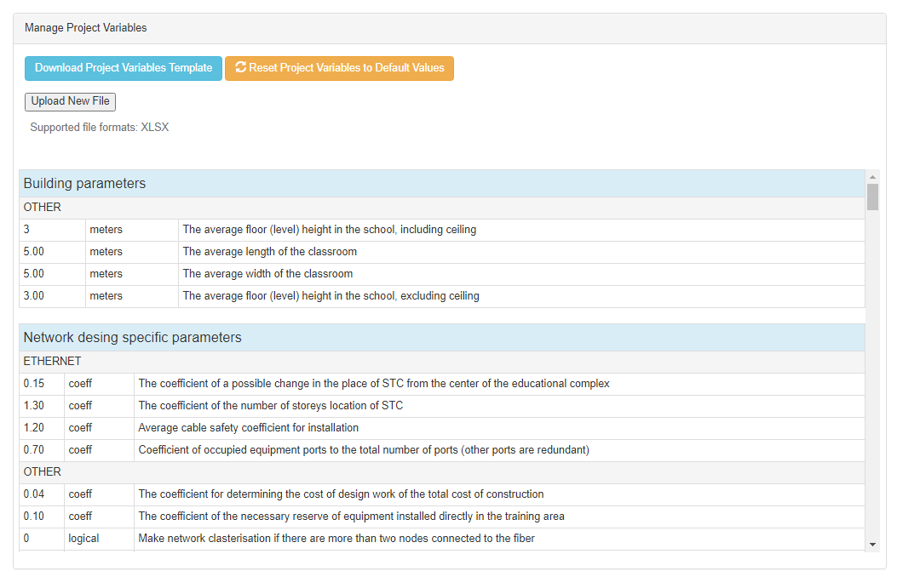

Figure 1– Manage Project Variables form

**PROJECT CALCULATION.**

If you want to calculate the project press button in MANAGING THE PROJECTS tab. After information input you’ll see “Calculation” options on the top of the window. Click 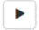 calculate the project (Figure 1.)

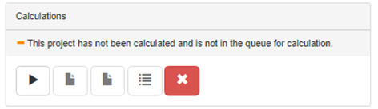

Figure 1– Manage Project Variables form

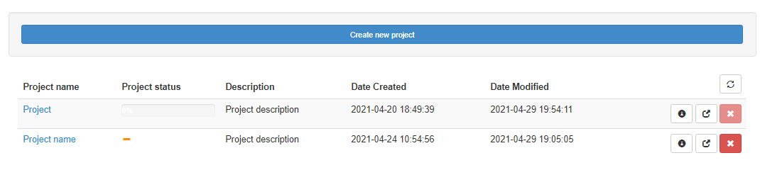

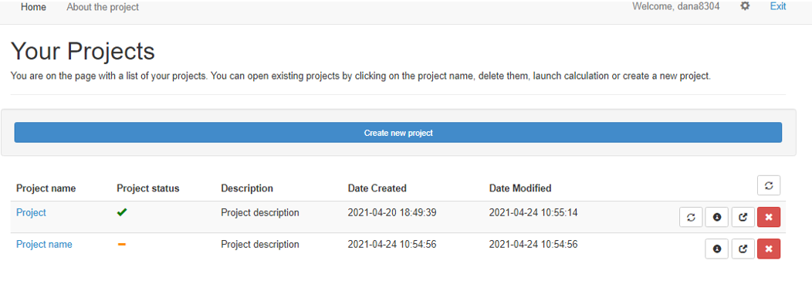

Figure 2– Manage Project Variables form

**DUPLICATING A PROJECT**

You can create new project with button “Duplicate the project” button .



**DELETING A PROJECT**

To remove file press 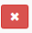 button on home page. Or same button in managing data entry template.



Figure 1 – Delate button on home page



Figure 2– Delate button on “managing data entry template“ page